**Trouble shooting for FFB controller issue**

1. Check the “0V-10V <=> -10V - 10V” jumper in the right position and the wiring between FFB controller and Servo is right, contact VNM if you are not sure.
2. Check for that every component on the board was soldered fully.

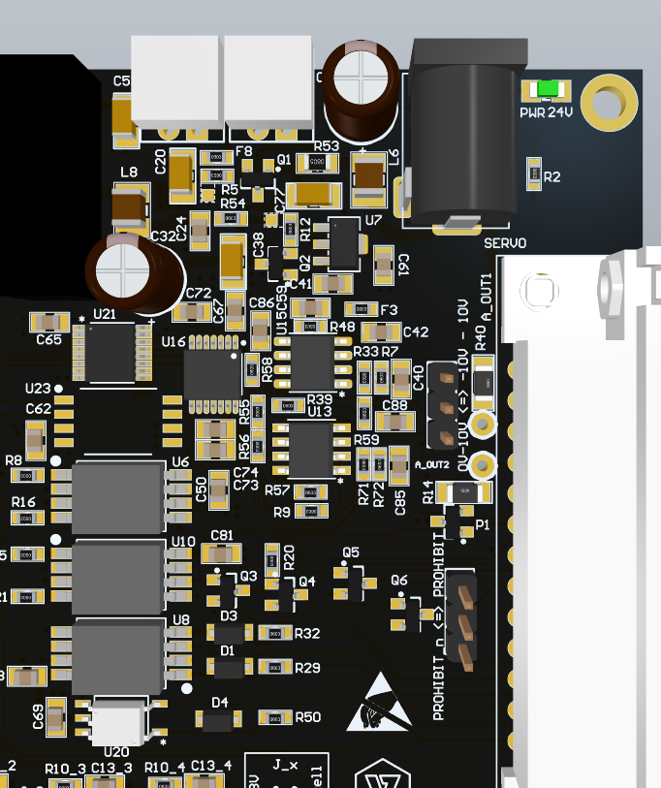

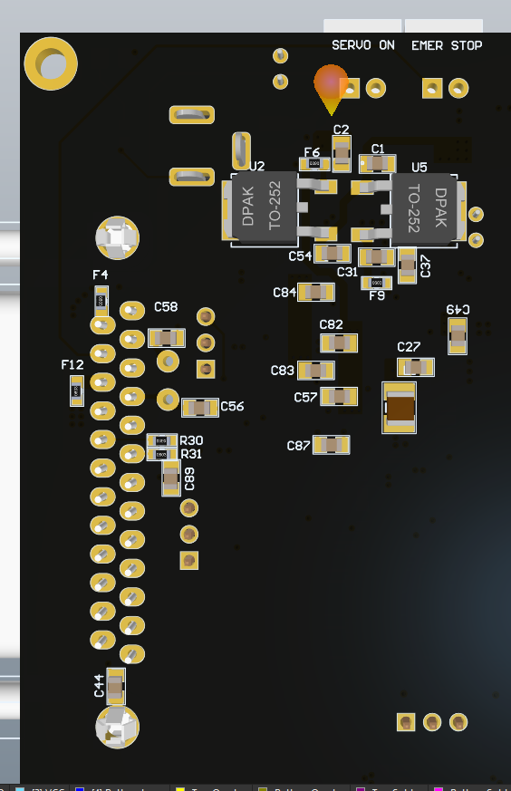

*U23, P1, R30, R31, C89 may absence in the FFB analog version.*

1. Measure analog output of the board:

Step 1: Plug FFB to PC, connect 24V power input.

Step 2: Measure the power supply in the board:

Step 2.1: Measure -12V power supply

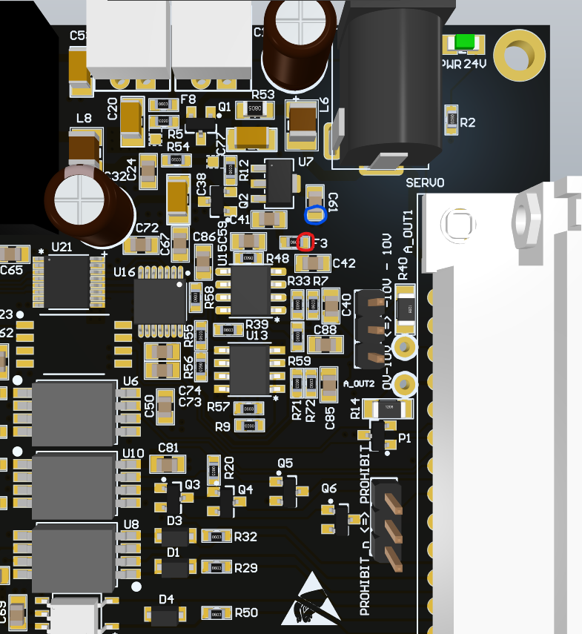

Measure between blue point and red point (black probe at blue point and red probe at red point) and make sure that have voltage about -12V. Write down this result (denote as V1) and report to VNM (V1 = …..V)

Step 2.2: Measure 12V power supply

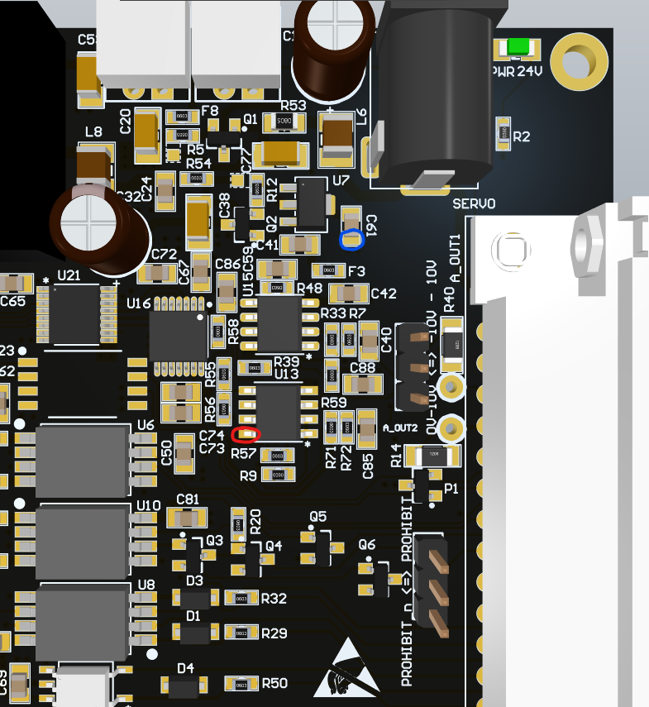

Measure between blue point and red point (black probe at blue point and red probe at red point) and make sure that have voltage about 12V. Write down this result (denote as V2) and report to VNM (V2 = …..V)

Step 2.3: Measure 5V power supply

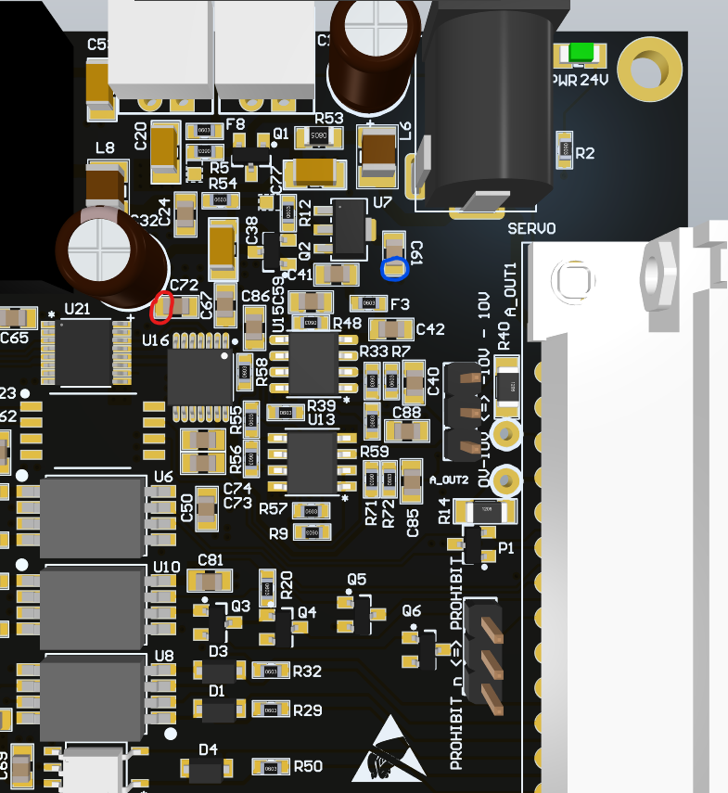

Measure between blue point and red point (black probe at blue point and red probe at red point) and make sure that have voltage about 5V. Write down this result (denote as V3) and report to VNM (V3 = …..V)

Step 3: If the are no problem in the above measurements. Continue to this step to check if board have analog output:

Step 3.1: Generate torque from computer sofware

Step 3.2:

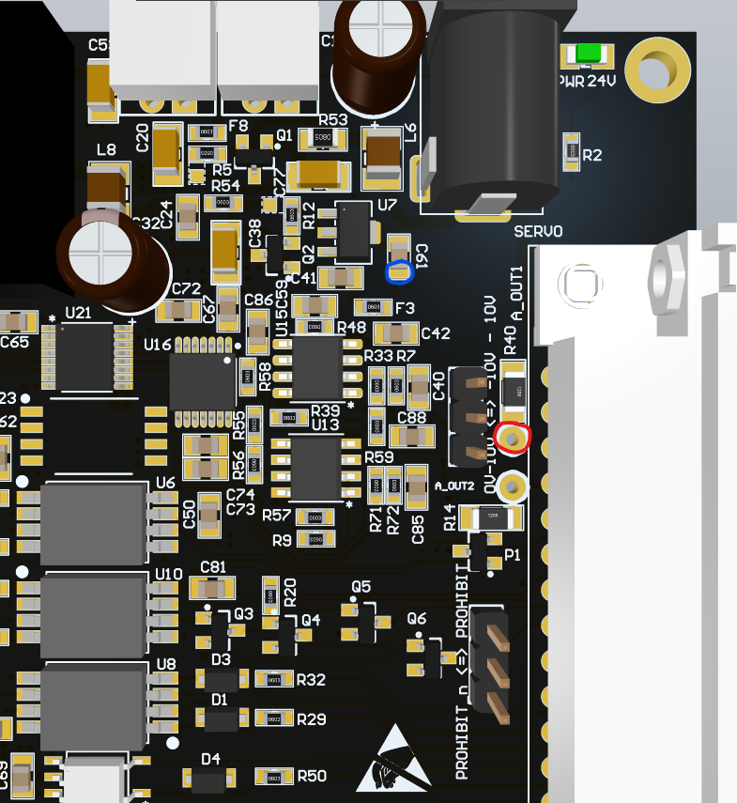

Measure between blue point and red point (black probe at blue point and red probe at red point) and make sure that have voltage different from 0V. Write down this result (denote as V4) and report to VNM (V4 = …..V)

Step 3.3:

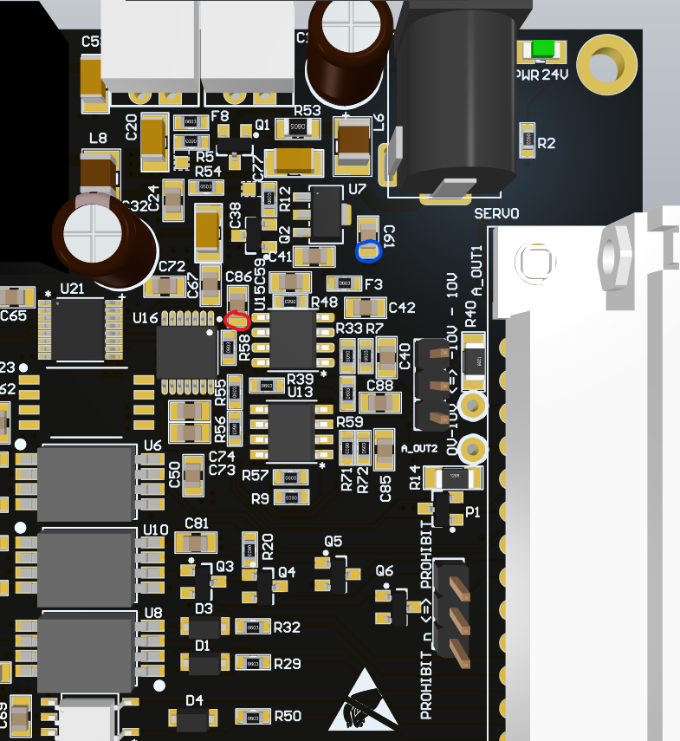

Measure between blue point and red point (black probe at blue point and red probe at red point) and make sure that have voltage different from 0V. Write down this result (denote as V5) and report to VNM (V5 = …..V)